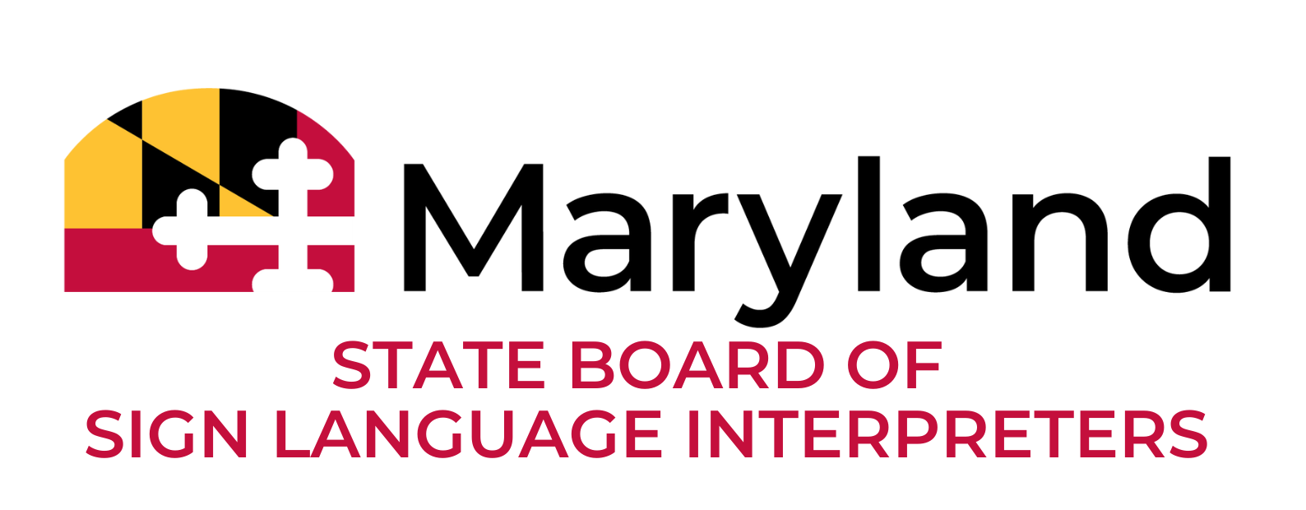
Board Special Meeting
November 18, 2025
7:30 PM

In Attendance
Board Members
Jacob Leffler, Chair and MDAD Representative
Leslie Puzio, Vice Chair and Community Member
Juliana Apfel, Community Member
Susan Beaver, Community Member
Nancy Gaskins, Community Member
Jim Skjeveland, PCRID Representative
Vacant, DeafBlind Representative
Governor’s Office of Deaf and Hard of Hearing (GODHH)
Usherla DeBerry, Director
Tanea Brown, Outreach/Interpreter Coordinator
Diamon Halliburton, Administrative Assistant
Others
Ethan Sonnenstrahl, Assistant Attorney General
Laura Gyamfi, Deputy Chief of Staff
Hannah Dier, Deputy Legislative Officer
Anna Rose and Gavin Gobble Baker, Interpreters
Community members (non-participating; viewers only)
The meeting was called to order at 7:38 PM
Chair Jacob Leffler welcomed all attendees and thanked them for joining the evening’s session. The agenda, previously posted on the website and available for review, was presented for approval.
Member Sue Beaver moved to accept the agenda as written, and Vice Chair Leslie Puzio seconded the motion. The motion passed unanimously, with all members in favor.

Chair Leffler led the introduction of all Board Members. He also welcomed the new Board Members to the State Board. He also noted that another newly appointed member, Juliana Apfel would be joining later in the meeting.
Chair Leffler explained that the purpose of the meeting was to discuss the current status of the interpreter regulations and acknowledged the difficulty of the update he was about to provide. Chair Jacob Leffler reported that the Governor’s Office had informed him that the regulations were being put on hold due to concerns raised by several stakeholders, including the Maryland Association of Boards of Education (MABE), the Maryland Hospital Association, and various educational organizations. In response to these concerns, the Governor’s Office plans to convene a stakeholder workgroup to develop revisions to the underlying statute and to introduce a revised bill in the next legislative session. Chair Jacob Leffler noted that he and Director DeBerry had engaged in multiple discussions over the past month regarding the pause, its implications, and the intended outcomes, while acknowledging the board’s concerns. He recognized the extensive work completed to date, including collaboration with consultants and former board members such as Trudy Suggs, Shane Feldman, Richie Bryant, and Kaylee Teixeira. The board was informed that regulatory work would not resume until Spring 2026, after the legislative session ends.
Director DeBerry confirmed on behalf of the Governor’s Office of the Deaf and Hard of Hearing acknowledgment of the board's significant efforts, the long-standing support of the interpreting community for the law, and the extensive work done to develop the portal and draft regulations. She expressed her gratitude to both past and present GODHH workers. She reaffirmed the Moore/Miller Administration's commitment to completing this work on behalf of the Deaf, DeafBlind, and Hard of Hearing community, emphasizing their right to effective communication access, ‘leave no one behind.’
Chair Leffler reiterated that the Governor’s Office had instructed the board to pause all regulatory development until the stakeholder work group completes its review of the statute. He reminded Board Members that the board submitted its regulations last year and had begun exploring alternative pathways, which would resume once the pause is lifted. Member Sue Beaver expressed her disappointment and concern about the pause in regulations. As a Child of Deaf Adults, she highlighted the ongoing struggle to access qualified interpreters and emphasized the importance of establishing regulatory standards. She compared interpreter licensure to other professions, noting that individuals are required to be licensed for services that are far less critical than ensuring communication access. Sue expressed her belief that delaying these regulations sends a discouraging message to the Deaf Community regarding their value within the State. Member Beaver conveyed that this decision made her feel as though the Deaf community was being left behind, emphasizing that Deaf Marylanders deserve qualified, licensed interpreters and full access to communication in all settings.
Vice Chair Puzio shared these sentiments, describing the decision as heartbreaking. She highlighted the decades of work that led to the current law and emphasized the extensive community engagement across two consecutive legislative sessions. During this time, stakeholders had the opportunity to testify, and the board made numerous revisions to the regulations during the 30-day public comment period. She questioned why concerns from a few stakeholder groups prompted a restart of the process. She expressed frustration that the board had not been notified earlier and requested clarity on who raised the objections and why the board was excluded from those discussions. She also inquired whether organizations such as the Maryland Association of the Deaf, the Potomac Chapter of the Registry of Interpreters for the Deaf (PCRID), or the Maryland Advisory Council on the Deaf and Hard of Hearing(MACDHH) had been consulted.
Member Jim Skjeveland expressed similar concerns, pointing out that many states already require certification to ensure that interpreters are qualified. He noted that Maryland, despite having a large Deaf population, risks falling behind. He emphasized the importance of making sure that Deaf and Hard of Hearing individuals are included as central participants in any future work group, rather than just having organizational representatives. Member Nancy Gaskins expressed confusion about the necessity of this decision.
Chair Leffler added that Maryland is home to more than 1.2 million Deaf and Hard of Hearing residents, emphasizing that this pause will significantly impact the community. As a Deaf individual, he highlighted that organizations like the Maryland Association of the Deaf have advocated for licensure for many years and expressed his concern about the potential harm that could result from further delays.
Member Skjeveland raised questions about the legal authority to pause duly enacted regulations, including whether the Governor’s Office has the power to override legislatively approved laws, whether the board has any recourse to object or appeal, and whether legal guidance is available to clarify these matters. Director DeBerry explained that this type of administrative pause has occurred under previous administrations, and her office is working to better understand the legal framework, as this is their first time navigating such an action. She assured members that the Governor’s Office intends to continue working toward implementation and does not view the pause as a withdrawal from ongoing efforts.
Chair Leffler invited representatives from the Governor’s Office to address the board. Deputy Legislative Officer Hannah Dier and Senior Policy Adviser Laura Gyamfi introduced themselves. Ms. Dier expressed appreciation for the board's extensive work and acknowledged the challenges involved. She noted that regulating a previously unregulated industry is inherently complex and reiterated the administration’s respect for the board's efforts.

Ms. Dier and Ms. Gyamfi provided additional context regarding the regulatory pause. Ms. Dier emphasized that this decision was made thoughtfully, recognizing the board’s considerable work and addressing significant concerns raised by various stakeholders about both the content of the regulations and the process used to develop them. She explained that, since this is a newly regulated industry, moving forward with regulations just before the legislative session could create confusion if proposed legislative changes were implemented. The pause aims to ensure clarity regarding any statutory amendments and to allow the board to incorporate those changes into the regulations before resuming its work.
Ms. Dier and Ms. Gyamfi reaffirmed that the administration fully supports regulation and licensure for qualified interpreters and has no intention of abandoning this process. Ms.Gyamfi added that the pause is intended to protect the board’s previous efforts and ensure they are applied effectively, noting that multiple meetings were held with legal counsel, Director DeBerry, and Chair Leffler before reaching this decision.
Chair Leffler requested clarification on the structure and purpose of the upcoming working group. Ms. Dier explained that an email would be sent to stakeholders and advocacy groups the next day to initiate the process. The goal of the working group is to reach a consensus on proposed legislative changes before the January legislative session. The stakeholders identified for participation include representatives from the Judiciary, the Maryland State Department of Education, the Maryland Hospital Association, and relevant groups.. The Board requested more details about the stakeholder selection process and the specific concerns that led to the formation of the working group.
Ms. Gyamfi explained that the Governor’s Office plans to include one or two board representatives, members of the Maryland Association of the Deaf (MDAD), and other relevant individuals for proper representation. Member Skjeveland emphasized the importance of prioritizing the Deaf and Hard of Hearing community as primary stakeholders. He expressed concern that the currently proposed participants may not fully reflect the experiences of the Deaf community.
Chair Leffler welcomed new board member Juliana Apfel, who joined the meeting and confirmed that she was up to date on prior discussions. Vice Chair Puzio reiterated concerns that the stakeholders initially mentioned by the Governor’s Office primarily represent hearing interests and complainants, rather than addressing the systemic barriers to effective communication faced by the Deaf community. She noted that the Board had voted on only a single technical amendment to the statute. She questioned whether the Governor’s Office had reviewed 2 years of committee testimony on the impact of unqualified interpreters on Deaf and Hard of Hearing individuals in critical situations.

Director DeBerry and representatives from the Governor’s Office acknowledged the concerns raised and confirmed that the working group had not yet been convened. They emphasized the importance of balancing community needs with effective government operations and noted that additional feedback from Deaf organizations and advocates would be incorporated. Chair Leffler and Board Members emphasized the need to include Deaf voices and lived experiences to ensure equitable access in medical, educational, and other critical settings. Member Apfel shared her perspective as a Deaf individual and licensed interpreter, highlighting the challenges of implementing licensure and regulations while affirming her commitment to supporting effective communication access within the community. The Board continued its discussion regarding the formation and composition of the working group for the Governor’s Office. Member Apfel emphasized the importance of including individuals with direct experience in American Sign Language and communication access, highlighting that the group should reflect the diverse language use and lived experiences of the Deaf community.
Vice Chair Puzio noted the need to involve the Maryland School for the Deaf and the Maryland State Department of Education to ensure that educational perspectives and language access for children of hearing parents are represented.
Chair Leffler requested clarification from representatives of the Governor’s Office, Ms. Dier and Ms. Gyamfi regarding the work group’s expected timeline, meeting frequency, and the process for identifying stakeholders. Ms.Dier and Ms. Gyamfi explained that outreach to stakeholders including Deaf community members, interpreters, and other relevant organizations, would begin immediately and that meeting schedules would be established once membership is finalized.
Member Skjeveland stressed that at least 51% of the work group should consist of Deaf or Hard of Hearing individuals to ensure that those most affected are represented in the majority. Ms. Dier and Ms. Gyamfi confirmed their commitment to substantial Deaf participation. They clarified that the work group would be small yet balanced, including board members, Deaf community representatives, and professional interpreters to ensure meaningful input and effective decision-making.
Board members emphasized transparency by listing the participating organizations and identifying individual members, ensuring the Deaf and Hard of Hearing community is fully represented. Questions were raised about licensure applicants and refunds, and Director DeBerry confirmed that FAQs addressing these issues would be posted on the GODHH website. Individual cases could be handled through direct contact.

Ms. Dier and Ms. Gyamfi clarified that the working group would be small, incorporating one or two board representatives to maintain a diverse yet manageable composition while adhering to Open Meetings Act requirements.

Ms. Dier reiterated that the working group's scope is limited to reviewing and proposing amendments to the underlying statute, not revising existing regulations. She stressed the importance of stakeholder collaboration. The board confirmed its understanding of the group's focus and continued deliberations on which members would participate, taking both representation and expertise into account.

The Board selected Member Apfel and Vice Chair Puzio to serve as the two board representatives, recognizing their combined experience and ability to advocate for both community and historical perspectives. Nancy expressed interest in observing and contributing as appropriate.

The Board welcomed new members, acknowledged the significance of the working group, and discussed logistics for the upcoming board retreat and meetings. The meeting concluded with expressions of appreciation to all participants.

The meeting was adjourned at 9:01 PM.

