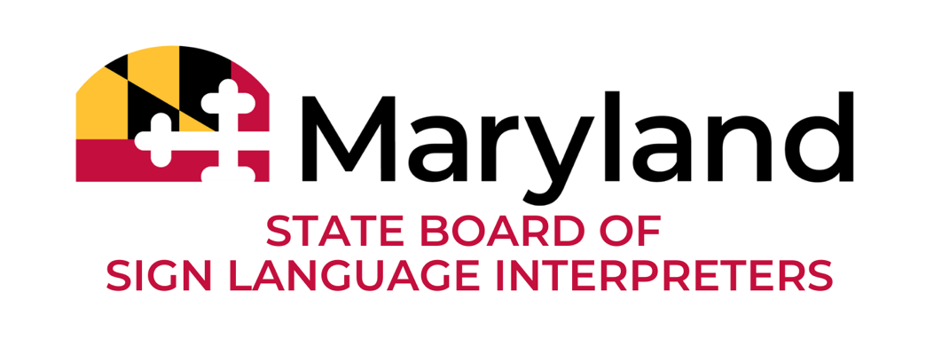
August 21, 2024
6:00-8:00 p.m.
Board Meeting Agenda

- Call to Order
  - Welcome
  - Note on closed session
  - Approval of minutes
- Board Updates: Chair Trudy Suggs
- ODHH Updates: Director Usherla DeBerry
- Reports
  - MDAD: Ritchie Bryant
  - PCRID: Vacant
  - Work groups
- Discussion
  - Regulations
  - Timeline
  - Seal
  - Logo
  - Website portal
  - Application process
- New Business
  - Amendments to bylaws
  - Communications
- Public comments received via email
- Adjournment

All previous meeting minutes and videos are available via odhh.maryland.gov. A portion of this meeting may be closed pursuant to Md. Code Ann., General Provisions Art. § 3-305(b).

